Primate Culture

* Most primates live in groups, tropical forests and therefore arboreal (living in trees)
* 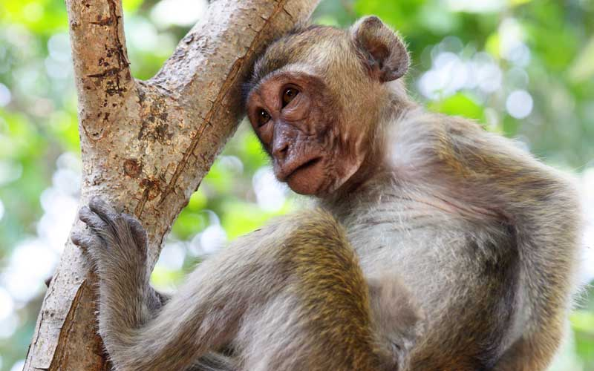
* Other primates have adapted to other habitats
* 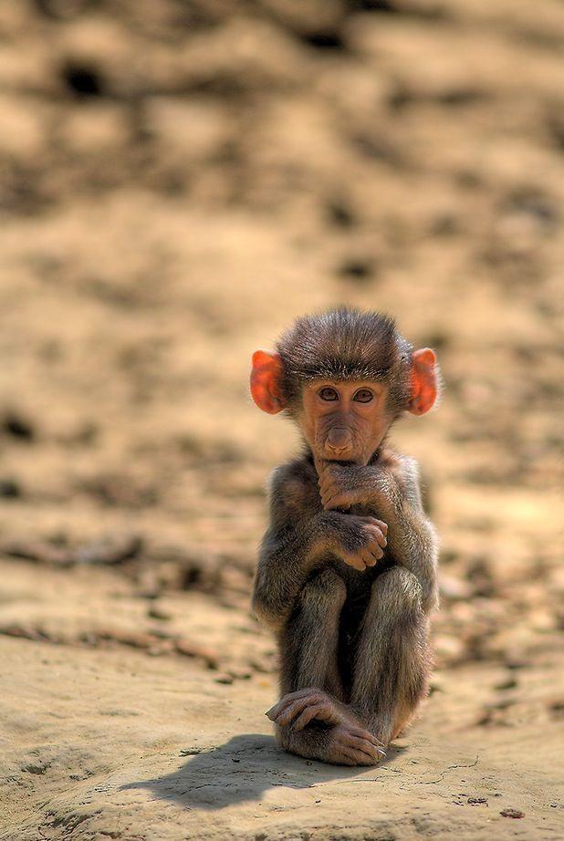

**The Evolution of Primate Social Behavior**

* **Proximate** causes/explanations: hormonal or physiological reasons to act (it feels good)
  + Reasons we have came up with to abstract away from the innate human condition
* **Ultimate** causes/explanations: deeper, evolved strategies that have been shaped over millions of years of selection.
  + Natural Selection’s reasoning

**Primate Socioecology:** study of how ecological forces shape the size and structure of social groups

**Ranging Behavior**

* All primates have home ranges, however only some are territorial
  + These species include Chimpanzees

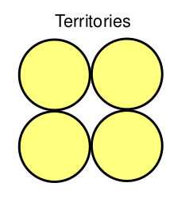

* + Strict and distinct boundaries between land possession. This is heavily enforced by the males of the species. Male Chimps will all get in a single file line, patrolling the borders to ensure there are no trespassers. Conflicts between patrols are very bloody if engaged.

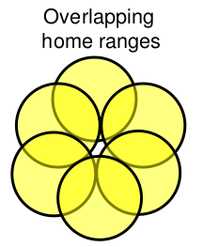

* + There is no clear distinction between who has land possession. This overlapping territory is introduced by females of the species, as they are peacemakers rather than aggressors.

**Reasons for Group Living**

* Overall better protection from predation
  + Safety in numbers
* **Paradox of Sociality**: the predation rates are higher for group living rather than solitary members of the groups. There are more animals present so it easier for the predators to have access to these members. This increases the stress levels of the individuals living in the group as they see their group members being eaten often.
* Predation is a significant source of morality among primates

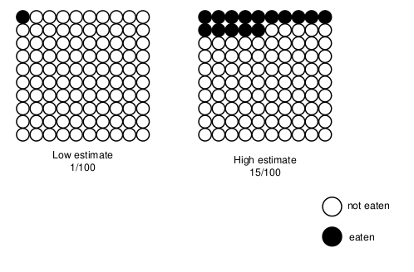

* **Sociality** is an effective anti-predator strategy
  + Detection
    - **Vigilance efficiency:** groups are more likely to detect predators because there are more on the lookout
  + Dilution
    - Saving yourself rather than the group
  + Deterrence
    - Groups can outnumber the predator
* **Interspecific mutualism**
  + Diana monkeys look out for ground predators
  + Red colobus monkeys look for eagles
  + Two species indirectly look out for each other as they have learned each other’s calls for predators, ultimately saving themselves from predation.

**\* Nocturnal animals fend for themselves rather than relying on a group \***

**Group Habits**

**Female Philopatry**

* Tight female bonds and more female-female affiliation, matrilineal inherited status (mother → daughter), more female resource defense
* Sexually mature males are booted from the group

**Male philopatry**

* Male bonded. Less female-female affiliation (grooming), more female-female competition (aggression, infanticide)
* Sexually mature females are booted from the group

**Sexual Relations**

* **Solitary**: males roam and find mates
* **Monogamy**: one partner for life
  + Those cultures that express monogamy have smaller sexual dimorphisms than those who do not
* **Polyandry**: multiple males to one female at the same time
* **Polygamy**
  + One-male
  + Multimale

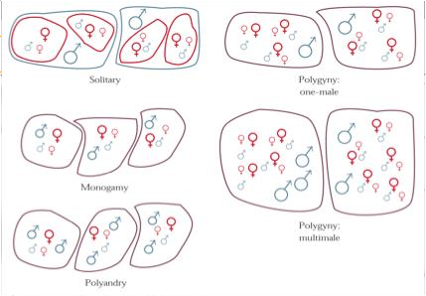

**Resource competition**

* Clumped resources
  + Contest competition

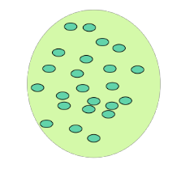

* + Example: 100 monkeys find an apple tree, everyone is fighting for an apple
* Dispersed resources
  + Scramble competition



* + Example: Kid hits a pinata and there is candy everywhere. Instead of fighting, kids take small amounts of resources and consume it elsewhere